2023 Antagene Website Update
Placing an Order for Histiocytic Sarcoma Risk Test/The English Version!
The Antagene website has changed recently, and combined with the fact that the BMDCA website is under construction, some of the links there are currently inaccurate. Here are updated instructions for ordering a new test on the Antagene website. You can also buy at a discounted price if you can get the blood sample to the 2024 National Specialty. We're having a BMDCA subsidized clinic at the Specialty on April 3.
The current procedure to purchase a new test from the Antagene website is to create an account here: https://antagene.com/en/my-animals. Login to your Antagene account, then click on 'My animals'. Click on ‘+ Add an animal’ (see green button on right side of the screenshot below) then add the dogs you want tested to your account.
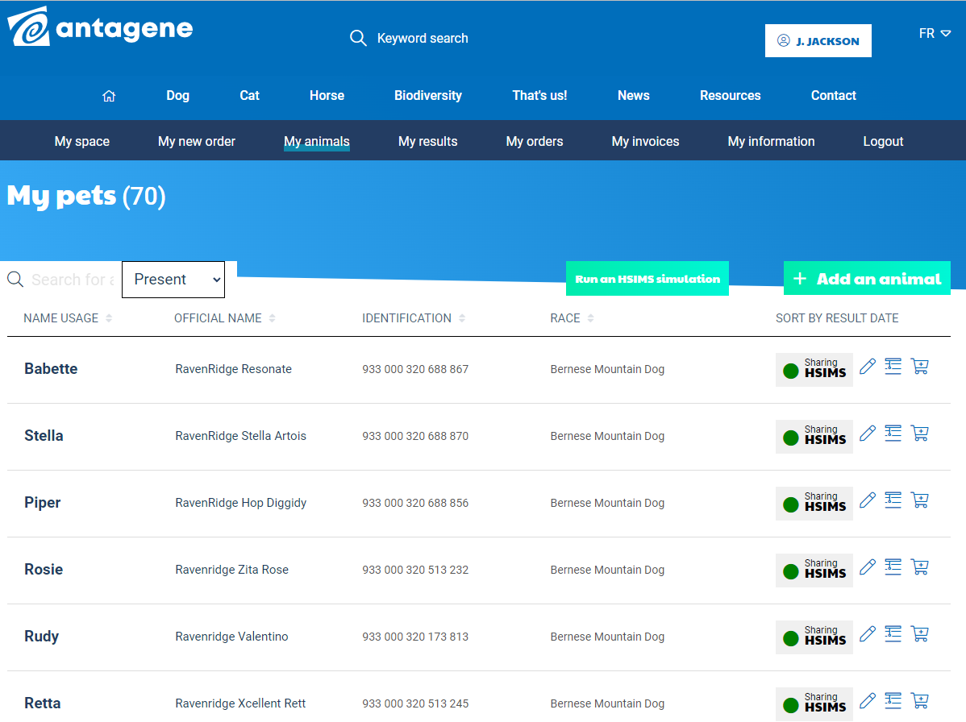

When you have entered your new dog into your list of 'my animals', click on the shopping cart to the right of their name.
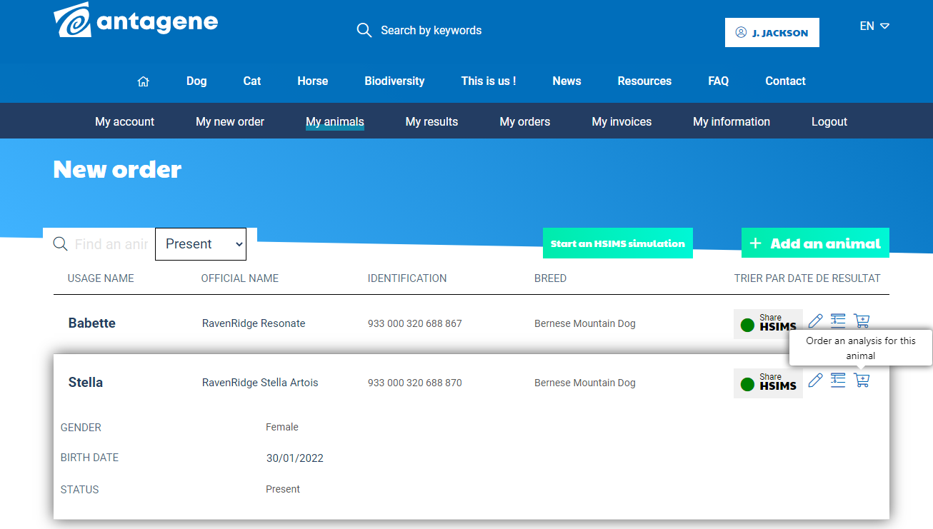
Then scroll down to Histiocytic Sarcoma, and 'add to my order'. Then go to your shopping cart at the top of the page under your account, and follow the prompts to make payment.
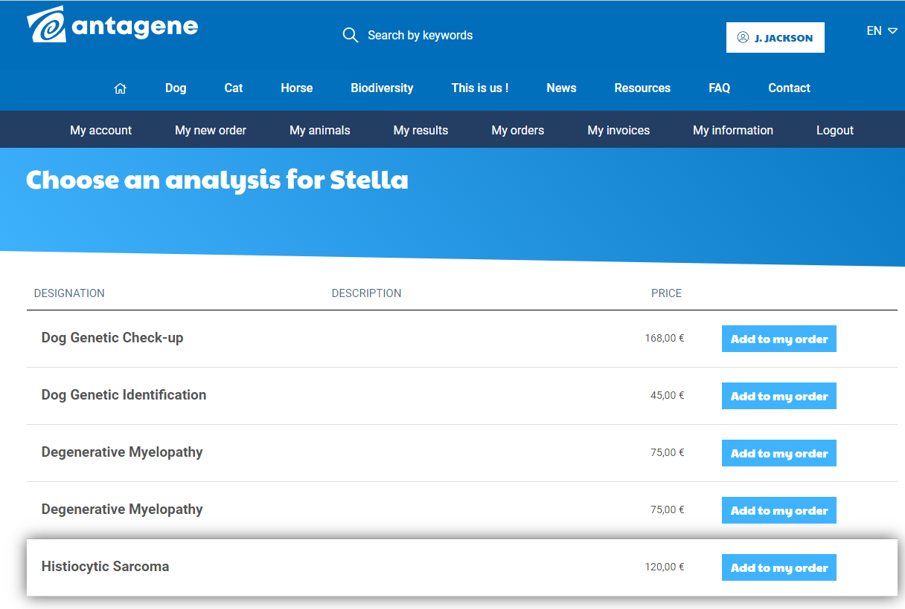
The paperwork you need to complete is located on the BMDCA website and is still current. Print and take the paperwork to your vet for their signature: http://bmdca.org/health/pdf/Antagene_sampling_certificate.pdf
If this is the first time you've done a histio test, you'll need to sign and also send the memorandum of agreement: http://bmdca.org/health/pdf/Antagene_HS_MOU.pdf. You only need to do this once, not per dog.
Include these in your shipment to Antagene, along with a copy of your invoice.

Last updated November 2023.

