2023 Update
Using the Antagene Histiocytic Sarcoma Index Mate Selection (HSIMS) Tool
The English version is back!
Julie Jackson
The Antagene Histio Risk Test was developed based on nine different markers on five chromosomes that have been found to have a link to histiocytic sarcoma in the Bernese Mountain Dog. Weighting of those nine marker values provides three different results: A – four times less likely to develop histio, B – neither more nor less likely to develop histio, and C – four times more likely to develop histio. Removing all B’s and C’s from the gene pool would undoubtedly do tremendous harm to the diversity of the gene pool, and the advice had been to avoid breeding a C to another C. But with the new HSIMS tool, even a C x C breeding might be an option.
Combining two copies of nine genes provides about 20,000 different results, so Antagene has developed a tool that can assist breeders. If two dogs are good breeding candidates for a bitch, this test can be used to determine which would give the best chance at a high percentage of A and B puppies. It is one trait in the complex determination of choosing an ideal mate.
HSIMS allows a breeder whose dog has been tested and listed in the HSIMS database to do ‘test matings’ of prospective mates who have also been tested and listed in the HSIMS database, to learn the statistical results of the puppies for the Histiocytic Sarcoma genetic risk test. It will show the percentage of A’s, B’s, and C’s for those 20,000 possible results. This test is free and available to anyone who has tested their dog for the Antagene HS Risk Test.
To use the tool, begin by logging into your Antagene account to access your tested dogs: https://antagene.com/en/authentification
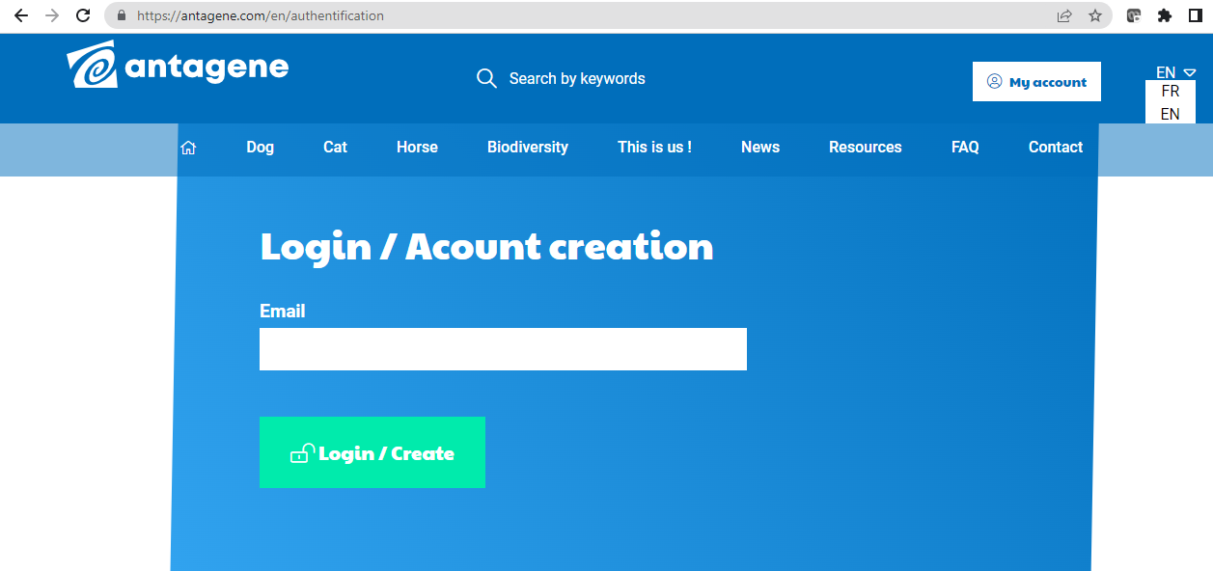

And click on ‘EN’ for the English version
Then click on ‘My Animals’ for the list of your dogs tested:
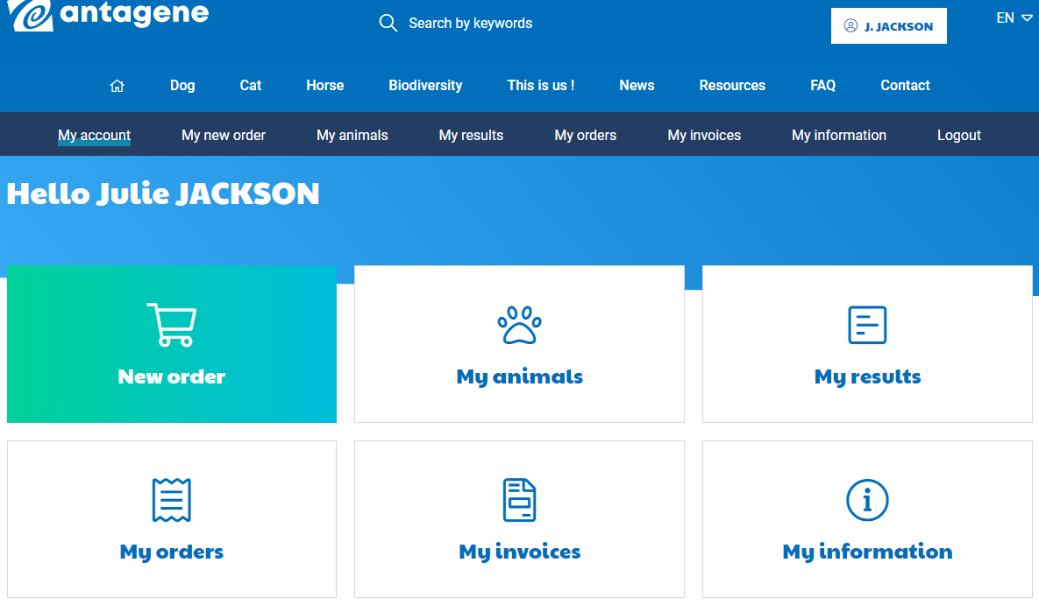

Next, click on the dog you want to do the test mating with, and make sure they’ve got the green light!
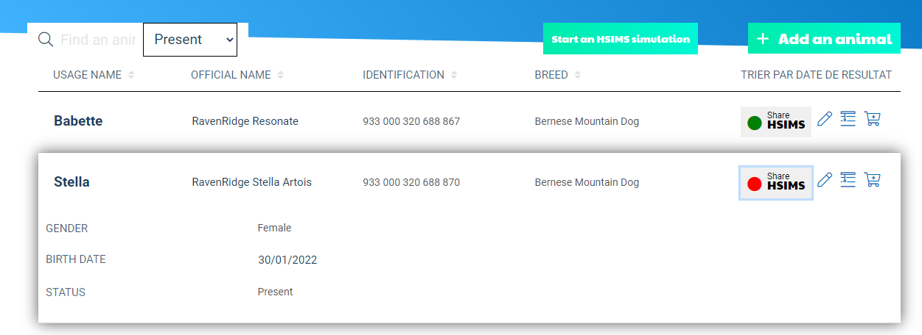
Click on the red ball to turn it to ‘green’. Now your dog can be used for a test mating!

NOTE: It’s important that ALL dogs be entered into the breeding pool, even if not a breeding dog!! The HSIMS results are much more accurate than the A/B/C indexes, and much information can be gained by relatives being used for “test matings”, beyond the famous show dog! Please green light ALL your dogs that have been tested.
And now you’re ready to do a test mating. Click on “start an HSIMS simulation’. Type the call name, registered name, or identification number of the first dog in the Search box, then click on ‘Select’. NOTE: At least one of the dogs must be listed under your name, ‘My Animals’.
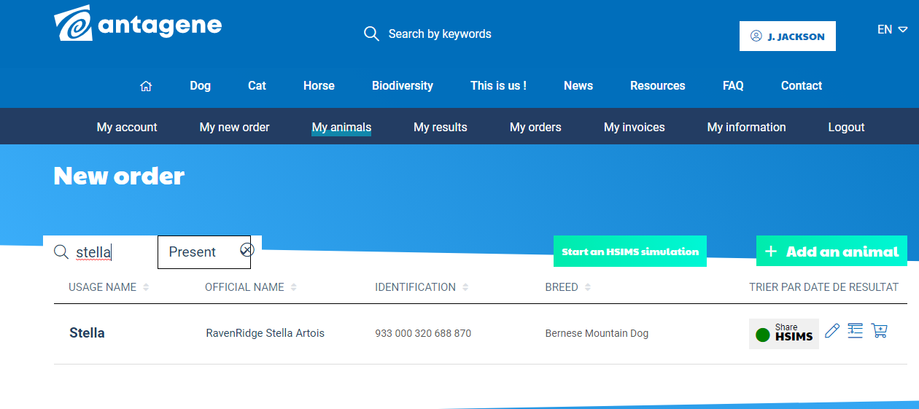

Then select a mate, using the same search method, and click on ‘select’:
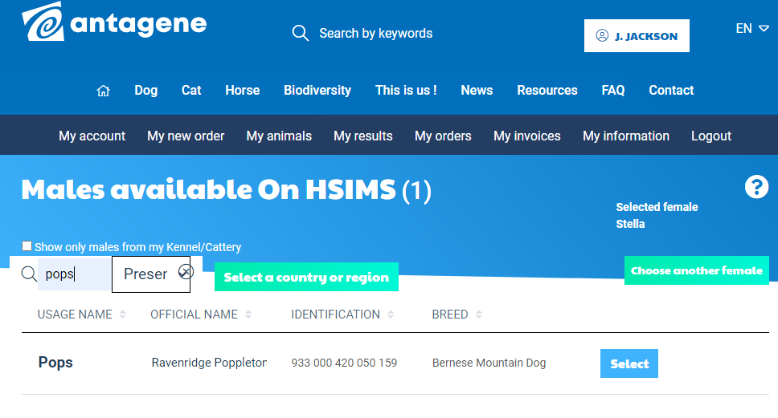

And here’s the results, shown in a pie chart, with percent risk for each index for the puppies:
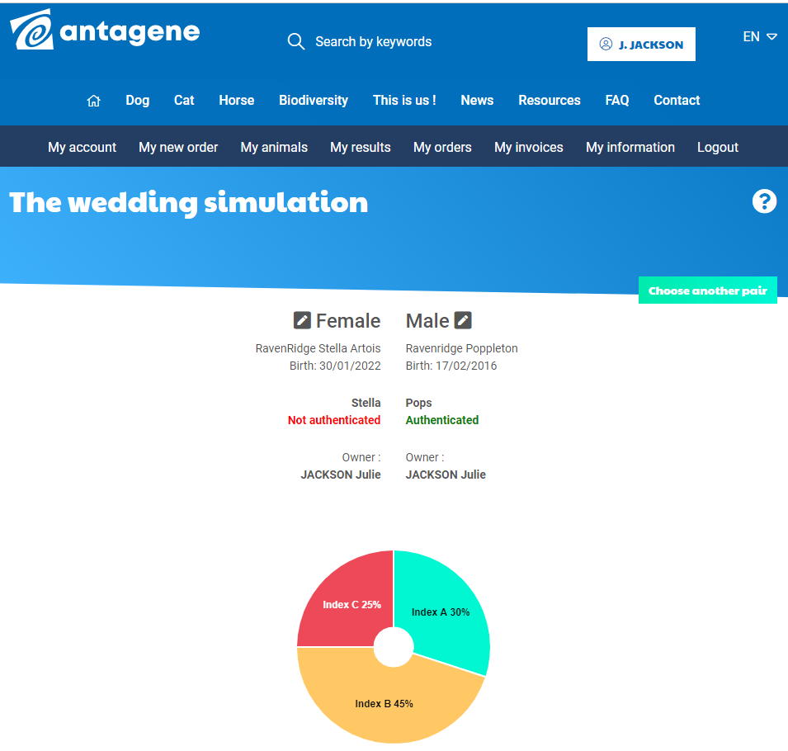

Breeders are cautioned that A x A matings are not always going to be the best solution. A’s can produce C’s, just as C’s may produce A’s. A breeding program approach that uses only A x A matings or selects only A mates for their dogs without using the HSIMS tool for predicted outcome probabilities may not be making the lowest risk breedings. HSIMS calculated outcome probabilities may be used to help breeders choose lower risk matings and gradually reduce the HS risk.

