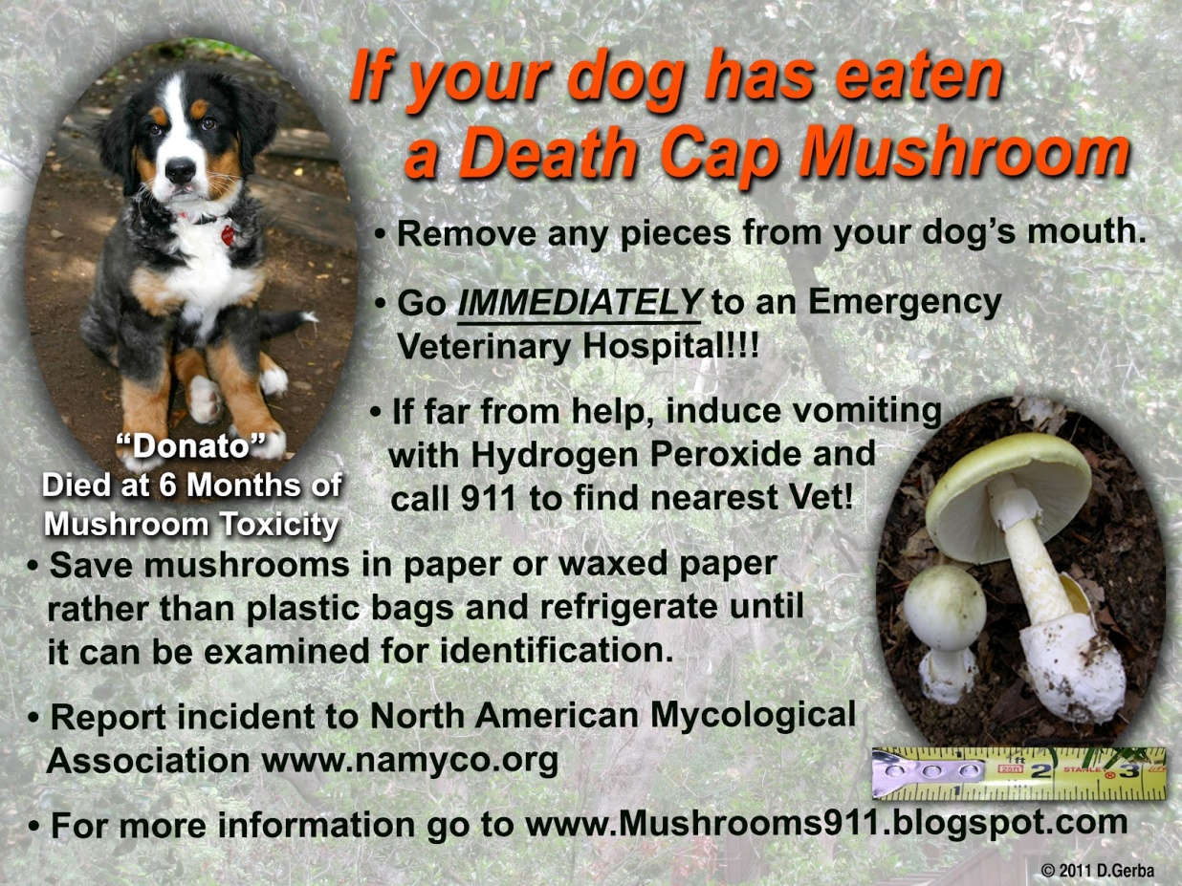

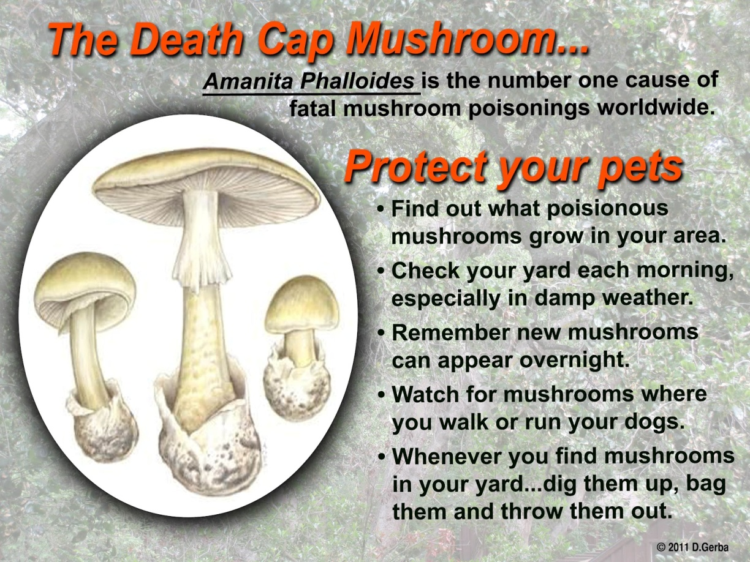

Great source for local information: www.psms.org/poisoning.php. I got this input regarding mushrooms in the Pacific NW from the Puget Sound Mycological Society: The deathcap mushroom (Amanita phalloides) does fruit here in the fall. Every spring we have several dog poisonings (especially puppies) from Amanita pantherina (the panther). The antidote is to make the dog vomit and rehydrate it, or to have the stomach pumped and rehydrated. Some small mushrooms growing in lawns also can give puppies Intestinal problems.

